PH126 Logic I  Fast Lecture 3
Lecturer: s.butterfill@warwick.ac.uk

The Syntax of FOL
We define what counts as a sentence of FOL using rules. E.g.:
1. If * and # are sentences, then so is(* ∧ #)
2. If * and # are sentences, then so is (* ∨ #)
3. P, Q, R, … are sentences
4. If * is a sentence, then ¬* is a sentence
So:
a. P is a sentence // rule 3
b. ¬P is a sentence // rule 4, a
c. ( ¬P ∧ Q ) is a sentence // rule 1, b, a

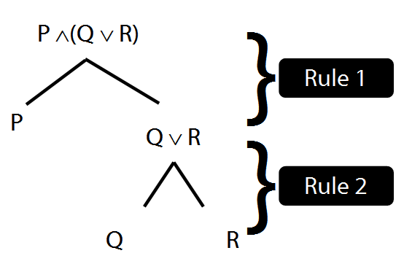
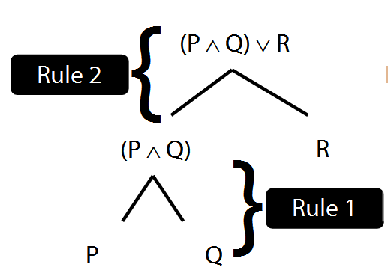
Rule of Proof: ∨Elim
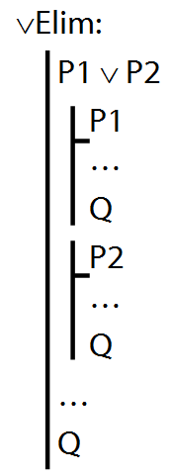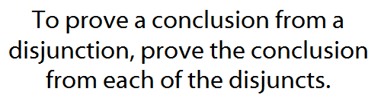

Example proof with ∨Elim
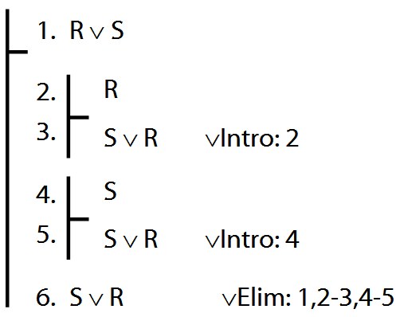

⊥, ¬
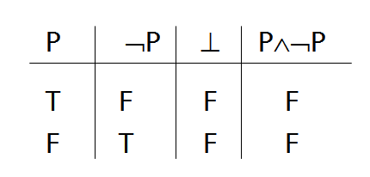
Proof example with ⊥Elim and ⊥Intro
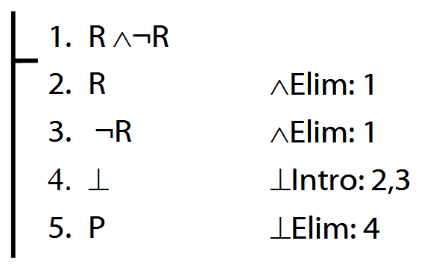
Proof example with ¬Intro
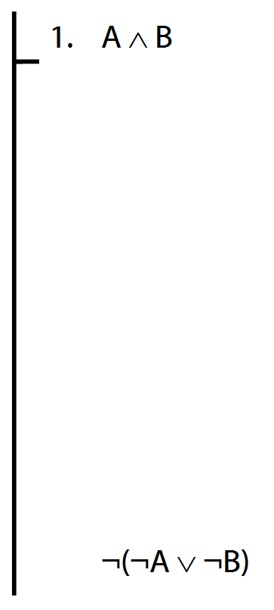
Rules of Proof for →
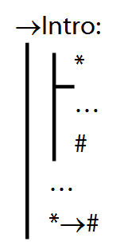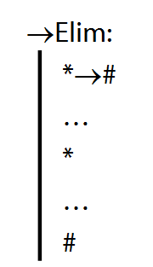

Proof example for →Elim (to complete)
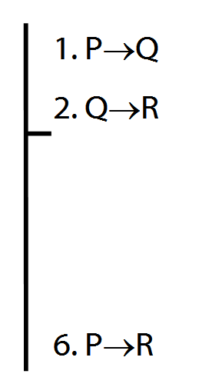

Not all proofs have premises
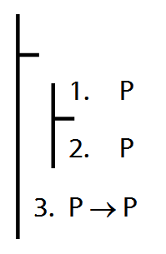
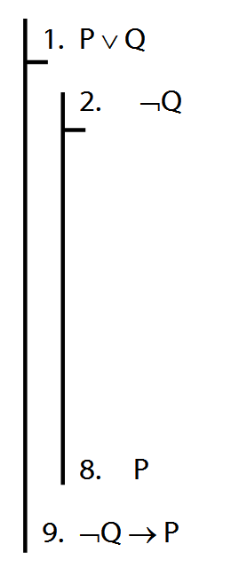

Scope
Which step of this proof is wrong? Why?
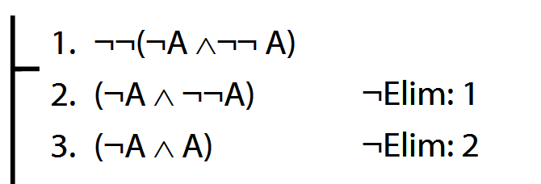

In P∧(Q∨R), the scope of ∧ is P∧(Q∨R)
In P∧(Q∨R), the scope of ∨ is (Q∨R)
In (P∧Q)∨R, the scope of ∧ is (P∧Q)
In (P∧Q)∨R, the scope of ∨ is (P∧Q)∨R
The scope of a connective is the smallest constituent expression which contains that connective.

Exercises 03
For your third seminar
Only for fast groups
7.2, 7.5, 7.6 (tt)
7.9 (truth functions)
8.20–25 (proofs/counterexamples)
9.8–10 (quantifiers)

Exercises 04
For your fourth seminar
Only for fast groups
7.25 (logical equivalence)
8.26–30 (proofs/counterexamples)
9.16.10–15 (translation)
9.17.7–15 (translation)
12.4 (counterexamples)
either
12.5–7 (counterexamples)
or (if possible)
12.8–12 (counterexamples)
NB. DO NOT USE TAUT CON. EVER.

